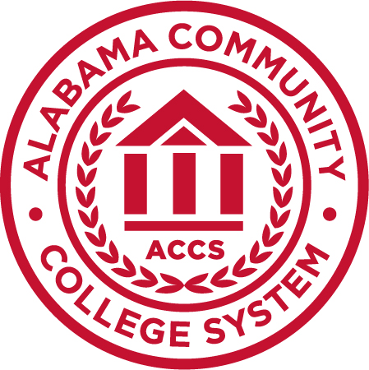

Jimmy H. Baker
Chancellor
P.O. Box 302130
Montgomery, AL 36130-2130
www.accs.edu

PRESS RELEASE

For more information, contact:
Rachel Adams
Communications and Marketing Administrator
rachel.adams@accs.edu
(334) 293-4651

October 11, 2018

Chancellor Announces Patricia Sims as President of J.F. Drake State Community and Technical College

MONTGOMERY, Ala. – At the Alabama Community College System board of trustees meeting on Wednesday, Chancellor Jimmy H. Baker announced the selection of Dr. Patricia Sims as president of J.F. Drake State Community and Technical College.

Sims has 25 years of experience in both K-12 and higher education. Most recently, she served as Dean of the College of Education at Athens State University in Athens, Alabama. Sims previously served at Drake State for more than 12 years as Student Services Management Director and Dean of Instructional and Student Services.

“Dr. Sims’ proven leadership and commitment to innovation and student success makes her the right choice for Drake State,” Baker said. “With unique experience in all levels of education, from teacher to principal to dean, Sims brings with her tremendous energy and enthusiasm and I am confident Drake State will flourish under her leadership.”

Sims began her career as a middle school science teacher at Stone Middle School in Huntsville. She served as Assistant Principal at Davis Hills Middle School and principal at Westlawn Middle School before she transitioned to higher education administration at then Drake State Technical College. Sims’ most recent position at Athens State University, a two-year upper level institution with a 100 percent transfer population, provided her with a unique perspective on the receiving end of community college graduates that will serve her well in her new role.

“My career as an educator, administrator, advocate, and community leader has prepared me for the role of president at Drake State,” Sims said. “I am passionate about the role Alabama’s community colleges play in preparing individuals for successful futures and I am committed to expanding this mission in the Huntsville community. It is an honor and a privilege to be selected to serve in this capacity and I look forward to working with Drake State’s faculty, staff, administration, and students to move the college forward.”

Sims earned a Bachelor of Science from the University of West Alabama and a Masters of Education from Alabama A&M University. She also received a Doctorate in Education from Vanderbilt University. Sims is an active participant in her community serving in leadership roles for a number of higher education organizations and other entities. She serves as a board of trustee member for both the Southern Association of Colleges and Schools Commission on Colleges (SACSCOC) Alabama Delegation and the Statewide Transfer and Articulation Reporting System (STARS)/Articulation and General Studies Committee (AGSC). During her prior service with the ACCS, Sims was a recipient of the Othel L. Washington Student Affairs Officer of the Year Award and a Chancellor’s Award Nominee for Administrator of the Year.

Sims’ tenure as president at Drake State will begin on December 1, 2018.

###

About ACCS – www.accs.edu The Alabama Community College System (ACCS) consists of 24 comprehensive community colleges, Marion Military Institute and the Alabama Technology Network (ATN). ACCS is committed to providing a unified system of institutions delivering excellence in academic education, adult education, and workforce development.

