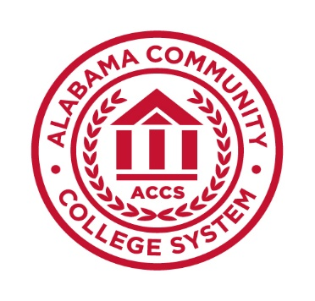
Alabama Community College System

NOTIFICATION OF INTENT TO SUBMIT A PROPOSAL (NISP)

FOR A NEW PROGRAM OF INSTRUCTION

College:

- Date of NISP Submission:

- Contact Person and Title:
Telephone:
E-mail:

Program Identification:

Award Level:
Title:
6-digit CIP:

Program Administration and Implementation:
Name of College/ School
Name of Dean
Name of Department
Name of Chairperson
Proposed program implementation date:
Anticipated ACHE meeting to vote on proposal:
Anticipated date of approval from ACCS Board of Trustees:
Other considerations for timing and approval (e.g., upcoming SACSCOC review):

Program Design:
Brief Description of Program and Objectives:

6. Program Design (continued):
- Proposed delivery format (In-person, online, hybrid):
- If hybrid, what % of program will be delivered online?

- Any other comments about program delivery:

- Please identify any specialized accreditation agency that may apply to this
program and explain why your institution does or does not intend to seek specialized accreditation.

- Will the curriculum require work-based or experiential learning (internship,
practicum, etc.)? If yes, please explain.

- Will the program be designed to meet educational requirements licensure
and/or certification required for entry-level employment? If yes, please list license and/or certification(s).

7. Relationship to other programs within the institution:
- Is the proposed program associated with any existing offerings? If yes, please explain. If this is a graduate program, please list any existing undergraduate programs which are directly or indirectly related. If this is a doctoral program, also list related master's programs.

- Will this program replace any existing programs or specializations, options, or concentrations within existing programs? If yes, please explain.

Relationship to programs at other Alabama public institutions:
- List programs at the same degree level that use the same or similar CIP codes. If no similar programs exist within Alabama, please list similar programs offered within the 16 SREB states.

- If the proposed program duplicates, closely resembles, or is similar to any other offerings in the state, please provide justification for any potential duplication.

- If you plan to explore program collaboration with other institutions, please explain.

Projected program demand

- What is the primary methodology you will use to determine the level of student demand for this program? (Survey of current or former students, enrollments in existing programs or courses)

- What is the primary methodology you will use to determine state need for this program? (Labor market information, expert market analysis, state or regional economic development strategy)

