TO: ACCS Facilities Management

ACCS Project No.
ACCS Form 2-G

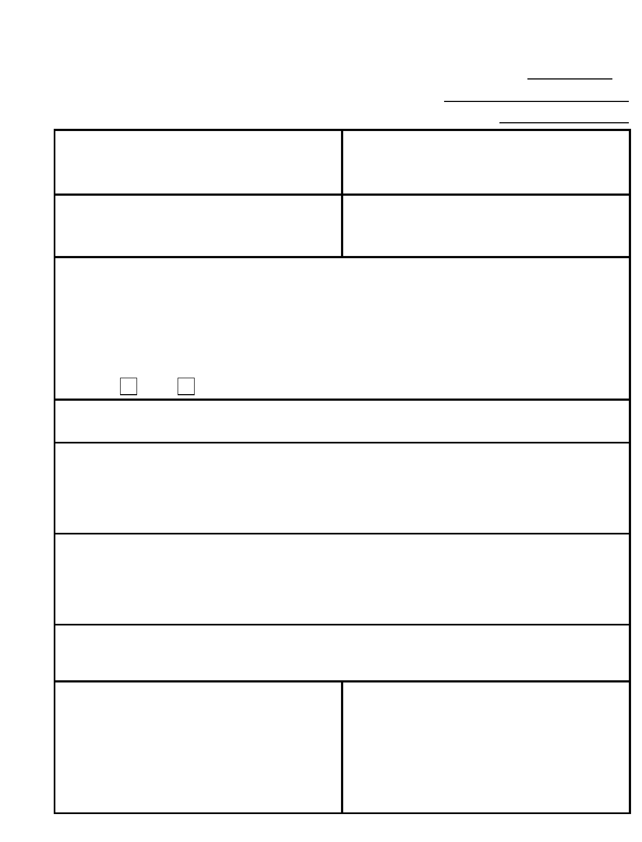
Purpose and instructions on next page.
Do not staple this form and/or attachments; use clips.
CHANGE ORDER JUSTIFICATION
Change Order No. Date:
PROJECT NAME & LOCATION: | OWNER ENTITY NAME & ADDRESS:
CONTRACTOR COMPANY NAME & ADDRESS: | ARCHITECTURAL / ENGINEERING FIRM NAME & ADDRESS:
DESCRIPTION OF PROPOSED CHANGE(S): ATTACH | CONTRACTOR'S DETAILED COST PROPOSAL(s)  TIME EXTENSION: _____ CALENDAR DAYS
AMOUNT: ADD DEDUCT $
ORIGINAL CONTRACT AMOUNT CONTRACT AMOUNT PRIOR TO
PREVIOUS C.O.'s _______ THRU _______ PROPOSED CHANGE ORDER

JUSTIFICATION FOR NEED OF CHANGE(S):
JUSTIFICATION OF CHANGE ORDER vs. COMPETITIVE BID:
ARCHITECT/ ENGINEER'S EVALUATION OF PROPOSED COST:
CHANGE ORDER RECOMMENDED | CHANGE ORDER JUSTIFIED AND APPROVED
ARCHITECTURAL / ENGINEERING FIRM NAME  By: | By:
ARCHITECT / ENGINEER'S SIGNATURE  By: | OWNER'S SIGNATURE  By:
OWNER'S PROJECT REPRESENTATIVE'S SIGNATURE | OWNER’S LEGAL COUNSEL'S SIGNATURE

Page 1 of 1

ACCS Form 2-G
CHANGE ORDER JUSTIFICATION: PURPOSE and INSTRUCTIONS
INSTRUCTIONS
The CHANGE ORDER JUSTIFICATION is to be prepared by the design professional, who has evaluated the fairness and reasonableness of the proposed cost of the change(s) and recommends that the proposed Change
Order be executed. The fully executed Form CHANGE ORDER JUSTIFICATION must accompany the proposed Change Order. Instructions for completing the Change Order Justification form are:
- Insert the proposed Change Order Number, date of the Justification, and ACCS Project Number in the spaces provided in the upper right-hand corner.
- Section (A): Insert the complete name and address of the PROJECT, OWNER(S), CONTRACTOR, AND ARCHITECT/ENGINEER.
- Section (B): Provide a complete description of the proposed changes in work, referring to and attaching revised specifications and/or drawings as appropriate. An attachment may be used if additional space is needed, but insert the proposed amount and time extension of the change(s) in the spaces provided. Attached a copy of the contractor's detailed cost proposal.
- Section (C): Insert the Original Contract amount, the net increase or decrease of previous Change Orders, and the Current Contract amount (preceding the currently proposed Change Order).
- Section (D): Explain why it is necessary, or in the public's interest, to make the proposed change(s) to the Work.
- Section (E): Explain why award of the changed work to the existing contractor instead of awarding the work under the competitive bid process is justified.
- Section (F): The design professional must state his or her evaluation of the reasonableness and fairness of the proposed costs based upon his or her review of the contractor's proposal.
- Section (G): The design professional must recommend the Change Order to the Owner by signing the document; the Owner may require such recommendation from other individuals.

