March 2024

CHANCELLOR’S PROCEDURE FOR POLICY
801.04: Admission: International Students

1. Required Admission Documentation.

For admission to an Alabama Community College System (ACCS) institution, an
international student must provide:

International First-Time Students | International Transfer Students
• Admission application  • A certified original translated and evaluated  copy of the student's high school transcript  if graduated outside of the United States  • A current and valid passport or other  official documentation to verify lawful  presence  • A current photo (passport-size, preferred)  • A minimum score of 5.5 on the  International English Language Testing  System (IELTS), a total score of 61 on the  Internet-based Test of English as a Foreign  Language (TOEFL), a 2A on the Step  EIKEN Test in Practical English  Proficiency, a total score of 500 on the  paper-based TOEFL, or a 95 on the Duolingo  English Test. Institutions may admit  students to an established ESL program in  preparation for the English Language Exam.  However, students may not enroll in regular  college courses until the English Language  requirement is met.  • A signed notarized statement verifying  adequate financial support  • Receipt of payment of I-90I Student and  Exchange Visitor Information System  (SEVIS) Fee.  • A medical health history with proof of  vaccination. Form is attached.  • Documentation demonstrating adequate  accident, sickness, and life insurance that  includes evacuation repatriation. Students  must maintain insurance coverage  throughout the duration of their 1-20. The  institution may provide an insurance plan or  a list of available insurance providers. | • Admission application  • A certified original translated and evaluated  copy of the student's high school transcript  verifying completion status and a translated and  evaluated transcript from each college attended  if graduated outside of the United States.  Students who have achieved a minimum of a  Baccalaureate degree are only required to  submit a translated and evaluated transcript from  the degree-granting institution.  • Original transcripts from all US institutions  attended  • A signed notarized statement verifying financial  support  • Copy of the student's current Form 1-20  • Receipt of payment of l-901 Student and  Exchange Visitor Information System (SEVIS)  Fee  • Copy of student's Visa and Passport  • A medical health history with proof of  vaccination (Form is attached.)  • Documentation demonstrating adequate  accident, sickness, and life insurance that  includes evacuation repatriation. Students must  maintain insurance coverage throughout the  duration of their 1-20. The institution may  provide an insurance plan or a list of available  insurance providers.

March 2024

CHANCELLOR’S PROCEDURE FOR POLICY
801.04: Admission: International Students

Other non-immigrant students must meet all ACCS admission requirements as well as provide documentation of immigration status as prescribed by the institution.

An international student who fails to provide the required documentation will not be admitted to any ACCS institution.

Each ACCS institution is responsible for reviewing the documentation to ensure the student
has adequate health and life insurance which is inclusive of a repatriation benefit. The
institution may provide a list of available insurance providers for international students seeking
coverage.

2. English as a Second Language Exam Waiver.

The English as a Second Language exam may be waived for students from all English-speaking
countries including but not limited to Anguilla, Antigua and Barbuda, Australia (Australian
English), the Bahamas, Barbados, Bermuda, Belize (Belizean Kriol), the British Indian Ocean
Territory, the British Virgin Islands, Canada (Canadian English), the Cayman Islands,
Dominica, the Falkland Islands, Gibraltar, Grenada, Guam, Guernsey (Channel Island English),
Guyana, Ireland (Hiberno-English), Isle of Man (Manx English), Jamaica (Jamaican English),
Jersey, Montserrat, Nauru, New Zealand (New Zealand English), Nigeria, Pitcairn Islands,
Saint Helena, Saint Kitts and Nevis, Saint Lucia, Saint Vincent and the Grenadines, Tanzania,
Singapore, South Georgia and the South Sandwich Islands, Trinidad and Tobago, the Turks
and Caicos Islands, The Gambia, the United Kingdom, the U.S. Virgin Islands, and the United
States.

Other waivers, with substantial documentation, must be submitted to the Chancellor for
approval.

3. Admission to an ACCS institution does not ensure admission to any individual program or
course. Institutions are expected to comply with all applicable accreditation requirements and
standards regarding program admission.

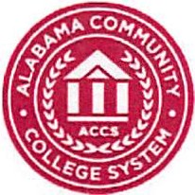

Immunization Form

To ensure the health and safety of our campus, immunizations against communicable disease is extremely important. Vaccination against Measles, Mumps, Rubella (MMR), Tetanus, and Meningococcal is required, as well as a negative Tuberculosis skin test. This is a requirement for all International Students. This form must be completed and submitted prior to admission in any ACCS institution.

Name

Last First Middle SS#/ID

Address

Street City State Zip

Date of Birth I I Contact Number Email

Section A: Required Immunizations/Tests
 |  |  | Month/Day/Year | Month/Day/Year
1. Meningitis Vaccine- within the last 5 years (Menomune, Menactra, Menveo)
2. Measles, Mumps, Rubella (MMR)
3. Tetanus
4. Tuberculosis Screening
TB Skin Test by PPD | Date Placed | Date Read | MM | Neg Pos
Chest X-Ray (if positive PPD or lab) | Date | Result | Submit copy of chest X-ray report

Section B: Recommended Immunizations
Please attach documentation of all childhood vaccinations (copy of Blue Card)
 | Month/Day/Year |  | Month/Day/Year
TD (Tetanus/Diphtheria)
AND/OR Tdap (Tetanus/Diphtheria)
Polio
Hepatitis B
Varicella (Chickenpox)

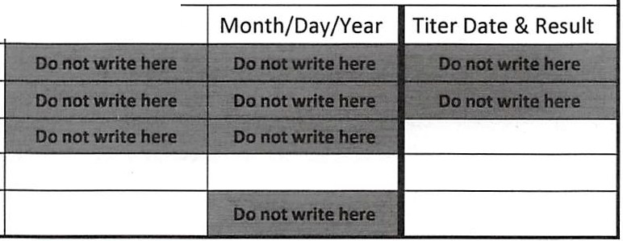
I certify that the above dates and vaccinations are true.

Signature of License Health Care Professional or Authorized Individual Date

Complete and return to:

