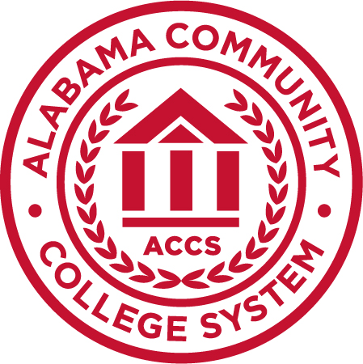

Jimmy H. Baker
Chancellor
P.O. Box 302130
Montgomery, AL 36130-2130
www.accs.edu

PRESS RELEASE

For more information, contact: Rachel Adams
Communications and Marketing Administrator
rachel.adams@accs.edu
(334) 293-4651

January 31, 2019

SCHOLARSHIP TO FUND 50 HIGH SCHOOL, COLLEGE STUDENTS’ PATHS TO AUTOMOTIVE MANUFACTURING CAREERS

MONTGOMERY – The path to fill more than 10,000 automotive manufacturing jobs within two years will be even more affordable in 2019 for 50 students in Alabama.

The Alabama Automotive Manufacturers Association and Alabama Community College System have partnered to provide a total $180,000 in scholarships, as well as mentors, to 50 students who want to pursue a technical education certificate or associate degree in the automotive manufacturing industry. The deadline to apply is Feb. 28.

Interested students with at least a 2.5 GPA can learn more information and apply directly through the website, https://dreamitdoitalabama.com/aama/. A full submission for the scholarship requires the following: a completed application; a maximum 500-word essay on why the student wants to work in Alabama’s automotive industry; one signed reference letter; an unofficial college or high school transcript; and a headshot photo.

Applicants must use the scholarship toward one of the 14 following declared majors of study or another automotive-related program: Automotive Manufacturing Technology; Automotive Manufacturing; Automotive Service Technician; Computer Numerical Control; Engineering Technology; Industrial Electronics Technology; Industrial Maintenance Technology; Injection Molding; Logistics; Machine Shop/Tool Technology; Manufacturing Technology; Mechanical Design Technology; Mechatronics; or Welding Technology.

ACCS has community colleges in every region of the state that offer one or more of the programs.

AAMA President Ron Davis said the scholarship program was designed to build interest in the exciting and rewarding careers the automotive industry offers. “As Alabama’s auto industry continues to grow, skilled workers are vital to our industry’s continued success,” he stated.

Jeff Lynn, ACCS’ Vice Chancellor of Workforce and Economic Development, said the scholarship opportunity is just one of several efforts ACCS is executing with its partners this year in order to continually provide world-class training that meets Alabama’s industry needs.

“The best advice we gather for how to educate an excellent workforce for Alabama’s employers and entrepreneurs is from direct input on what industries need,” he said. “Partnerships we’re creating to build programs that build futures for all Alabama residents require our investment in career technical education, and we’re committed to doing so locally, regionally, and statewide.”

###

About AAMA
Since 2001, the Alabama Automotive Manufacturers Association (AAMA) has provided awareness of manufacturing trends, techniques and concerns within the automotive manufacturing industry through interaction among automotive companies in Alabama. The association’s mission is to promote growth and continuous improvement of automotive manufacturing in Alabama.

About ACCS
With 24 community colleges in more than 130 locations, the Alabama Community College System (ACCS) is Alabama's gateway to first-class, affordable education and technical training to compete in a constantly evolving workforce. More than 168,000 Alabamians benefit from the various certification, credential, dual enrollment and degree programs ACCS offers alongside leading industry partners. The system includes the Alabama Technology Network, which provides extensive training and service offerings directly to business and industry. ACCS is governed by the Alabama Community College System Board of Trustees.

